To, DATE: 21/10/2025 TRUE NUTRITION
KODUNGAIYUR
07676131368
DEAR SIR;

We are glad to inform you that we are in the Painting and Cleaning industry for the
past 12 years and we do Interior and exterior painting, wall graphics, 3D paintings, starting from 900 to 100000 Sq. using traditional and latest technology Unifying Expertise.

After a through survey of your site we are herewith submitting our proposal for the painting of your above property.
S.  No | Description | Amount in INR
1. | INTERIOR WALL PAINTING:  ASIAN PAINT TRACTOR EMULSION:  - APPLY TWO CODE PREMIER EMULSION  SHYNE INTERIOR WALLS CEILING  - WALL PUTTY AREA TWO CODE  TOTAL PROJECT VALUE : RS.93,000 | RS.93,000

List of Machineries and consumables

- Airless Sprayer with latest technology
- Sanding Machine
- Vacuum Cleaner
- Putty blades
- Sanding paper
- Leveling tool
- Ladders or Sessor Lift
- Banian waste
- etal paste
- Wall putty
- Primer
- Thinner
- Brush and rollers
- Masking papers
- Safety equipment.

Looking forward for your favourable orders. Please call - 9500065813.

Terms & Conditions
- GST 18% Extra
- 50% Payment in Advance and the balance on completion of work.
- Water and power supply to be provided by you.
- Apart from the above mentioned jobs, if yours require additional services Please inform before the issuing work order.
- Scaffolding charges will Extra

Your satisfaction is our Goal. Looking forward for your favourable orders.

.

Regards

Klean Max Client Signature

K. SRIDHAR

Operations Head 9710148218 / 7338882034

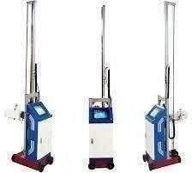
UPCOMING OUR FURTURE TECHNOLOGY; 3D WALL PRINTING MACHINE:
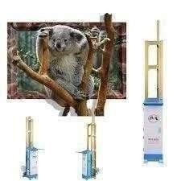

ROBOTIC PLASTRING AND PAINTING MACHINE ;



